Short Bio
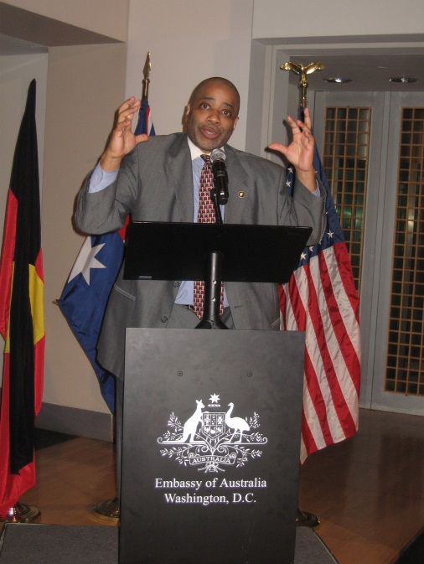
Raynard Jackson is President and CEO of Raynard Jackson &Associates, LLC--a government/public relations and political consulting firm in Washington, D.C. He has a proven record of balancing public policy with fundamental freedoms associated with a free-market, capitalistic society.
In today's world, characterized by tight budgets and corporate down-sizing, RJA understands that it must show real value for the client's bottom line. They encourage clients to view their fees as an investment, not as an expense. Then they establish reasonable goals by which their performance can be measured.
After spending years in corporate finance & accounting, Raynard decided to start RJA. RJA focuses on four areas:
Political consulting. They work with governors, senators, and congressmen helping them design campaign strategies to reach minority communities. This includes identifying what groups to speak to, writing copy for radio & TV commercials and fundraising.
Government Affairs. They work with trade associations & other special interest groups to help them design strategies to educate members of Congress about their corporate agenda.
Public & International Relations. They work with presidents from various African countries helping them improve their relations with the executive & legislative branches of the U.S. government. They also help them build relations with the U.S. business community in the areas of trade and investment.
Athletes & Entertainers. They work with many professional athletes & entertainers (both active and retired from NBA, NFL,MLB, recording artists, actors) helping them with strategic business advice and with their charitable initiatives.
He writes a weekly syndicated newspaper column in over two hundred newspapers, is a political analyst for TV station WUSA*9 (the Washington, DC CBS affiliate), and had an award winning internet radio show. His show, “Talking Right with Raynard Jackson,” has been recognized for the past two years in Talkers Magazine’s “Frontier Fifty.” The “Frontier Fifty” is a selection of the top 50 most Outstanding Talk Media Webcasters.
He also hosted a nationally syndicated radio show on XM/Sirius with Radio One (the largest owner of Black radio stations in the U.S.).
He is a native of St. Louis, MO, and is one of the most sought after conservative speakers in America. He is also a frequent public speaker to college students, political & business groups churches, etc. His views are frequently heard on radio and TV shows like Larry King, G. Gordy Liddy, Rush Limbaugh, CBS, NBC, ABC, Fox News Channel, Black Entertainment Television, etc.
He has written and been quoted in hundreds of newspapers from across the country, including: the Washington Post, Washington Times, Detroit Free Press, the Houston Chronicle, Jet Magazine, Emerge Magazine, the National Journal, etc.
He has done extensive travel and work throughout Africa and has proven to be a true friend of Africa.
He has an undergraduate degree in Accounting from Oral Roberts University in Tulsa, Oklahoma and a graduate degree in International Business from George Mason University in Fairfax, Virginia.

